Final Project
Title:
Driver Drowsiness detection system for Truck Drivers
Abhijeet Chaudhari, Harshilkumar Patel, Kishan Patel and Rishav Rana

Introduction
Driver drowsiness is a serious problem on the roads today, and it can lead to deadly accidents. Drowsiness is considered a transition from arousal to sleep. The first sign of drowsiness is the inability to keep one’s eyes open. Frequent closing of one’s eyes makes it impossible to perform their task effectively.
The National Highway Traffic Safety Administration estimates that drowsy driving is responsible for over 100,000 crashes, 40,000 injuries, and 1,550 deaths each year in the United States alone. To address this issue, driver drowsiness detection systems have been developed to monitor drivers and provide alerts when they are at risk of falling asleep behind the wheel.
Recent advancements in deep learning techniques have shown great potential in the development of accurate and reliable driver drowsiness detection systems. These systems use deep learning algorithms to analyze data from various sensors, such as cameras, accelerometers, and electroencephalography (EEG) signals, to detect signs of drowsiness and fatigue in drivers.
This capstone project focuses on the development of a driver drowsiness detection system using deep learning algorithms. The system will mainly use camera to detect driver’s state. It can be done using a camera mounted in the vehicle that captures video footage of the driver's face. Deep learning algorithms can then be used to analyze the video footage and detect changes in the driver's facial expressions, such as drooping eyelids, yawning, or changes in the shape of the mouth. These changes can indicate that the driver is becoming drowsy or fatigued.
A deep learning model will be trained using a dataset of labeled images and videos of drowsy and alert drivers. The model can be trained to recognize patterns in the driver's facial movements and predict the likelihood of drowsiness. Once the model is trained, it can be integrated into a driver drowsiness detection system that monitors the driver in real-time and provides alerts when signs of drowsiness are detected. The alerts can take the form of visual or audible warnings, such as flashing lights or sounds, to prompt the driver to take a break or stop driving.
Overall, using a camera and deep learning for driver drowsiness detection is a promising approach that can improve road safety by alerting drivers when they are at risk of falling asleep at the wheel.
Objectives
- Increased safety: Drowsy driving or working can lead to accidents and mistakes. Early detection of drowsiness can help prevent accidents and ensure the safety of individuals.
- Improved productivity: When individuals are alert and awake, they are more productive and efficient in their work. Drowsiness detection can help ensure that individuals are alert and performing at their best.
- Early intervention: Early detection of drowsiness can allow for early intervention, such as taking a break or resting, to prevent further fatigue and drowsiness.
- Cost-effective: Drowsiness detection using deep learning can be cost-effective compared to traditional methods such as hiring a dedicated observer or using expensive equipment.
- Non-invasive: Drowsiness detection using deep learning can be non-invasive and non-disruptive to the individual being monitored, which can lead to greater acceptance and compliance.

Related work
We went through different studies that are going under the field of drowsiness detection. One of the works that we review was Driver Drowsiness Detection using Deep Learning published by IEEE. The article emphasises how crucial it is to stop car accidents brought on by fatigued driving and suggests a Sleepiness Detection System that can detect when a driver's eyes are closed for a brief period and inform them via an alarm. The technology employs deep learning to discern whether the driver's eyes are open or closed, and when it determines that they are closed, it sounds a warning. Using a CNN model, the system obtains an accuracy of 86.05% on a huge dataset of 48000 photos. The proposed technology might considerably lessen car accidents brought on by fatigued driving and increase traffic safety.
The detection strategy was applied by some researchers to applications for smartphones. Recurrent neural networks (RNNs) were employed by Ed-Doughmi et al. in Y to identify fatigued driving. The NTHU-DDD video dataset was employed in this study's RNN model training. Data samples were taken from video recordings of various driving conditions. There are 849 video segments totaling around 7 seconds in the overall dataset. Six convolutional layers, four max-pooling layers, one flattening layer, and two fully linked layers make up the proposed multilayer architecture. To notify trustworthy contacts, this solution connects a smartphone application to a web server. Eventually, using the conv3d 3D RNN technique, the suggested system offers 92% validation accuracy in the detection of fatigued driving.
In Dasgupta and his associates developed a smartphone-based fatigue detection system using the percentage of eye closure (PERCLOS) approach. To ascertain the statuses of the drivers, the system employs the PERCLOS metric. The system assesses the voice-to-unvoiced ratio using the smartphone's microphone after exceeding the PERCLOS threshold. To satisfy the active state, the system requires the driver to make an active touch reaction. The system generates the alarm and sends an SMS to the trusted contacts if the driver's response is not recorded. The classification of the writers' exhaustion status was 93.33%.
Using the Nvidia Jetson Nano developer kit, Arduino Uno, and AD8232 heart rate module, other work (Computer vision-based approach to detect fatigue driving and face mask for edge computing device) shows a comprehensive embedded system to identify weariness while driving. The system uses deep learning, computer vision, and heart rate monitoring. The suggested system can keep track of the driver's current circumstances, analyse them for signs of drowsiness, and take appropriate action. The integrated camera module always keeps an eye on the driver. The core system uses deep learning and computer vision techniques to retrieve and analyse the frames to verify the situation with Nvidia Jetson Nano. Using eye and mouth localization techniques from 68 different facial landmarks, the driver's states are determined. To categorise the states, experimentally generated threshold data is used. The integrated heart rate module tracks the heart rates continuously and looks for any change in BPM that would indicate tiredness. To deal with the current pandemic crisis, our system uses a convolutional neural network-based deep learning architecture to include extra face mask detection. To ensure continuous detection, the heart rate module operates in parallel while the other modules operate in a conditional sequential fashion. Any indication of sleepiness will be immediately detected, and an alert will sound. The system demonstrated 97.44% accuracy in tiredness detection and 97.90% accuracy in face mask identification during initial lab tests and certain real-world experiments.

Methodology
Detecting drowsiness in truck drivers is crucial for ensuring their safety on the road. Deep Learning is a powerful technique that has been widely used for developing effective drowsiness detection systems. We will be implementing the below methodologies for detecting the Truck Drowsiness:
- Convolutional Neural Networks (CNNs):

- The CNN model for drowsiness detection typically consists of several convolutional layers that learn various low-level features such as edges, corners, and color gradients, followed by several fully connected layers that learn high-level features and make the final classification decision. The model is trained on a large dataset of labeled images of drivers exhibiting various levels of drowsiness.

- During inference, the trained model takes in the input image of the driver's face and outputs a probability score indicating the level of drowsiness. The threshold for the score will be set based on the specific requirements of the application.

- To improve the accuracy of drowsiness detection, data augmentation techniques such as random cropping, flipping, and rotation will be used during training to increase the size and diversity of the training data. Transfer learning techniques can also be used to reuse pre-trained models for other related tasks, such as facial expression recognition or emotion detection.
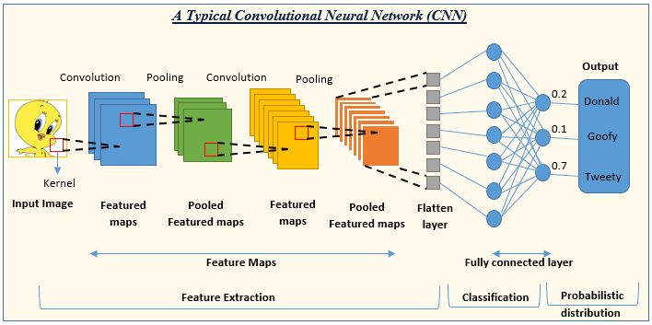
Fig. 1

- Recurrent Neural Networks (RNNs):

- Long Short-Term Memory (LSTM) is a variant of Recurrent Neural Networks (RNNs) that has been used for detecting yawning and nodding in drowsiness detection in truck drivers. LSTM networks are designed to handle the vanishing gradient problem that arises in traditional RNNs, making them more suitable for processing longer sequences of data.

- The LSTM model for detecting yawning and nodding typically consists of multiple LSTM layers that allow the model to capture long-term dependencies in the input data. The input data includes various sensor data such as facial landmarks and head position, which are used to detect yawning and nodding movements.

- During training, the model is trained on a large dataset of labeled sensor data from drivers exhibiting various levels of yawning and nodding. The model learns to identify patterns in the sensor data that are indicative of these movements.

- During inference, the trained model takes in the input sensor data and outputs a probability score indicating the likelihood of yawning or nodding. The threshold for the score can be set based on the specific requirements of the application.

- To improve the accuracy of yawning and nodding detection, data augmentation techniques such as random cropping and flipping can be used during training to increase the size and diversity of the training data. Transfer learning techniques can also be used to reuse pre-trained models for other related tasks, such as facial expression recognition or head pose estimation.

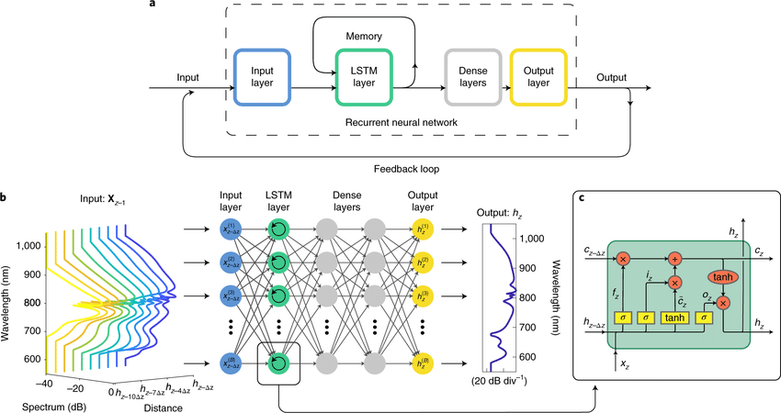
Fig 2

- Hybrid Models:

- Hybrid models are a combination of different deep learning models used for drowsiness detection in truck drivers. These models typically combine the strengths of multiple models to improve the overall accuracy and performance of drowsiness detection.

- One example of a hybrid model is a combination of Convolutional Neural Networks (CNNs) and Recurrent Neural Networks (RNNs). The CNNs are used to process the visual inputs, such as images or videos, and extract relevant features, while the RNNs are used to process the temporal aspects of the data, such as changes in driving behavior over time.

- Another example of a hybrid model is a combination of LSTM and CNN models. The CNN model is used to process the visual inputs, such as facial expressions or head pose, and extract relevant features, while the LSTM model is used to process the temporal aspects of the data, such as changes in yawning or nodding over time.

- During training, the hybrid model is trained on a large dataset of labeled sensor data from drivers exhibiting various levels of drowsiness. The model learns to identify patterns in the sensor data that are indicative of drowsiness.

- During inference, the trained model takes in the input sensor data and outputs a probability score indicating the level of drowsiness. The threshold for the score can be set based on the specific requirements of the application.

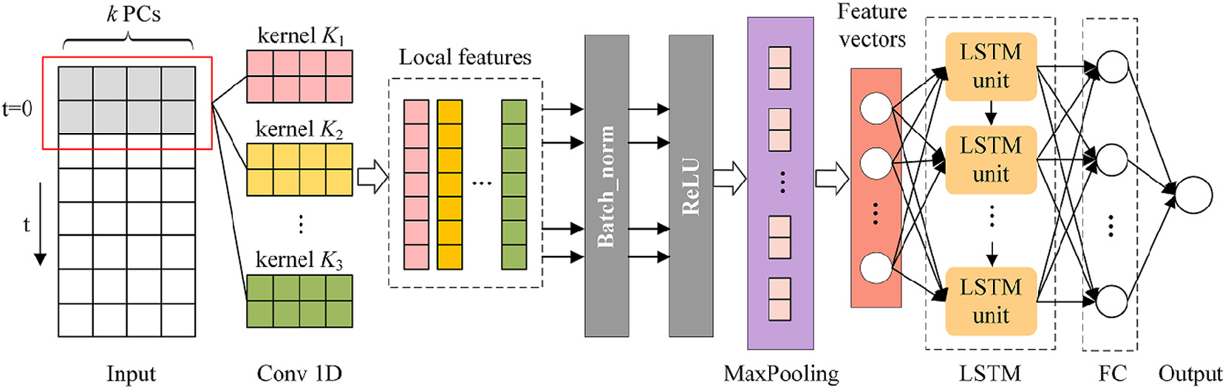
Fig. 3

- Transfer Learning:

- Transfer learning models have been used for drowsiness detection in truck drivers to leverage the knowledge learned from pre-trained models on large datasets to improve the accuracy of drowsiness detection on smaller datasets.

- One approach is to fine-tune pre-trained models such as VGG-16, ResNet, or Inception for drowsiness detection. These models have been pre-trained on large image datasets such as ImageNet and can be fine-tuned on smaller datasets of driver images to identify features related to drowsiness such as yawning or nodding.

- Another approach is to use pre-trained models for other tasks such as facial expression recognition or head pose estimation, and then transfer the learned knowledge to drowsiness detection. The pre-trained models can be fine-tuned on a dataset of driver images to identify features related to drowsiness, such as facial expression changes or head pose changes.

- During training, the pre-trained models are either fine-tuned or used as feature extractors on the driver images, and the model is trained to classify the level of drowsiness based on the extracted features.

- During inference, the trained model takes in the input driver images and outputs a probability score indicating the level of drowsiness. The threshold for the score can be set based on the specific requirements of the application.

- Ensemble Methods:
- Ensemble methods have been used for drowsiness detection in truck drivers to improve the accuracy of the models by combining the predictions of multiple models.

- One approach is to use multiple instances of the same model with different initialization and training configurations, also known as bagging. The output of each instance is combined using majority voting or averaging to obtain the final prediction.

- Another approach is to use multiple different models with different architectures or trained on different datasets, also known as model stacking. The outputs of each model are combined using techniques such as weighted voting or stacking to obtain the final prediction.

- During training, the ensemble method is trained on a large dataset of labeled sensor data from drivers exhibiting various levels of drowsiness. The models are trained independently or with different initialization and training configurations.

- During inference, the input sensor data is passed to all the trained models, and their predictions are combined to obtain the final prediction.

Libraries:
Libraries used for detecting Drowsiness of Truck Drivers using Deep Learning:

- TensorFlow: TensorFlow is a popular Deep Learning library that provides various tools and APIs for building and training Deep Learning models. It can be used for developing drowsiness detection models based on CNNs, RNNs, or hybrid models.
- Keras: Keras is a high-level Deep Learning library that provides a user-friendly interface for building and training Deep Learning models. It can be used for developing drowsiness detection models based on CNNs, RNNs, or hybrid models.

- OpenCV: OpenCV is an open-source library that provides various computer vision algorithms, including facial recognition and tracking. It can be used for detecting facial features associated with drowsiness, such as drooping eyelids and yawning.

- Dlib: Dlib is a C++ library that provides various machine learning algorithms, including facial recognition and tracking. It can be used for detecting facial features associated with drowsiness, such as eye closure and head movements.

- PyTorch: PyTorch is a Deep Learning library that provides a flexible and dynamic approach for building and training Deep Learning models. It can be used for developing drowsiness detection models based on CNNs, RNNs, or hybrid models.

Summary of Models used:

- Convolutional Neural Networks (CNNs)

- Our Open and Close Eye Dataset contains a total of 1452 images, which was further split into 3 datasets i.e., Training, Validation and Test in the following ratio:
Training Data | 70%
Validation Data | 10%
Testing Data | 20%

- Our Baseline model, got 96.93% accuracy in training and 91.78% accuracy on the test set.

- We did Data Augmentation on our model to artificially increase the size of a dataset by generating new data from existing data, but our accuracy decreased to 84.58%, 80.21% on the on-training data and test data set.

- Our Final CNN model consists of 2 layers each of Conv2d, Batch Normalization and Maxpooling and ANN consists of 3 Dense, 1 Flatten and 1Dropout layer. After doing the Hyperparameter tuning of our model, we got 99.43% and 93.15% accuracy on the accuracy in Training and Test data set respectively.

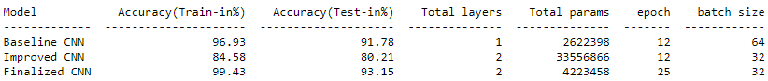

Future Work:

- Recurrent Neural Networks (RNNs)

We will try to explore the potential of using transfer learning techniques along with LSTM models to improve the performance and reduce the training time of drowsiness detection systems.

- Hybrid Models:

We will be examining the effects of various data sources (Yawning, Nodding and Eye movements) on the functionality of the hybrid model and investigate the best fusion techniques for merging data from various modalities.

- Transfer Learning:

We will investigate the impact of different pre-trained models (e.g., VGG16, VGG19) on the performance of transfer learning-based drowsiness detection systems and explore the optimal ways to fine-tune the models for better generalization ability.

- Ensemble Methods:

We will explore the potential of using meta-learning techniques to learn the ideal ensemble strategy for a specific drowsiness detection task, as well as developing more sophisticated ensemble techniques that can incorporate domain knowledge and prior information to improve the diversity and quality of the individual models in the ensemble.

Conclusion:
We have successfully developed a CNN machine learning model with accuracy of 95% that is quite efficient in generalizing and predicting the sleepiness of truck drivers using the open and closed eye dataset.
Machine learning algorithms can precisely determine when a person is feeling sleepy by detecting variations in eye activity, such as eyelid closure time and blink frequency. This technology has the potential to improve safety in various industries, such as transportation and healthcare, by providing real-time feedback to drivers and medical professionals.
However, the model could be made more reliable. Additions like yawning and nodding behind the wheels could increase the system's effectiveness and dependability. As a result, we will continue to work on the project while adding these features to increase the system's stability.
References:
[1] Yeresime Suresh, Rashi Khandelwal, Matam Nikitha, Mohammed Fayaz, Driver Drowsiness Detection using Deep Learning, IEEE, 7-9 Oct. 2021

[2] Y. Ed-Doughmi, N. Idrissi, Y. Hbali, Real-Time System for Driver Fatigue Detection Based on a Recurrent Neuronal Network, J. Imagining, 2020

[3] A. Dasgupta, D. Rahman, A. Routray, A smartphone-based drowsiness detection and warning system for automotive drivers, IEEE, Nov-2019

[4] Ashiqur Rahman, Mamun Bin Harun Hriday, Riasat Khan, Computer vision-based approach to detect fatigue driving and face mask for edge computing device, Science Direct, October 2022.

APPENDICES
The dashboard, dataset and jupyter notebooks could be accessed through the github repository:

